PodIntel AI – Podcast Analysis System
Documentation Generated On: February 23, 2026

1. Introduction
PodIntel AI is an AI-powered podcast/audio analysis system that processes uploaded audio files and extracts structured insights including topic segmentation, summaries, sentiment analysis, and keyword extraction. The system is built using FastAPI for backend processing and Streamlit for the frontend interface.

2. Objectives
- Automate podcast/audio content analysis
- Perform accurate speech-to-text transcription
- Segment content into meaningful topics
- Generate summaries for each topic
- Perform sentiment analysis
- Extract meaningful keywords

3. System Architecture
Frontend: Streamlit
Backend: FastAPI
AI Modules: Whisper, Sentence Transformers, TF-IDF, TextBlob
Audio Processing: FFmpeg, Pydub
Data Storage: Session-based folder system

4. Technology Stack
- Python
- FastAPI
- Streamlit
- OpenAI Whisper (Speech-to-Text)
- SentenceTransformers (Topic Segmentation)
- Scikit-learn (TF-IDF)
- TextBlob (Sentiment Analysis)
- NLTK (Sentence Tokenization)
- FFmpeg (Audio Conversion)

5. Complete Pipeline Workflow
Step 1: Upload audio via Streamlit
Step 2: Convert audio to 16kHz mono WAV format
Step 3: Chunk audio into fixed segments
Step 4: Transcribe audio using Whisper
Step 5: Clean transcript text
Step 6: Perform sentence segmentation
Step 7: Topic segmentation using embeddings
Step 8: Generate summaries
Step 9: Perform sentiment analysis
Step 10: Extract keywords
Step 11: Save results per session

System Architecture
The system consists of a Streamlit frontend for user interaction, a FastAPI backend for processing requests, and an AI pipeline that performs audio conversion, transcription, NLP analysis, and result generation.
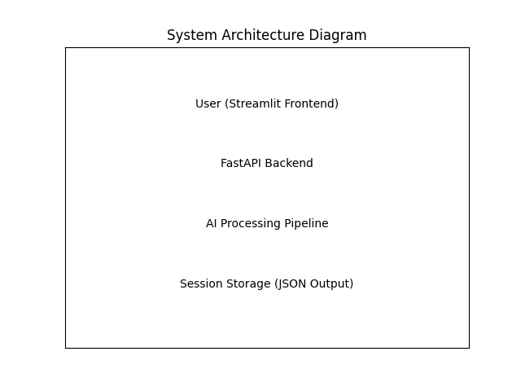

Sample Workflow

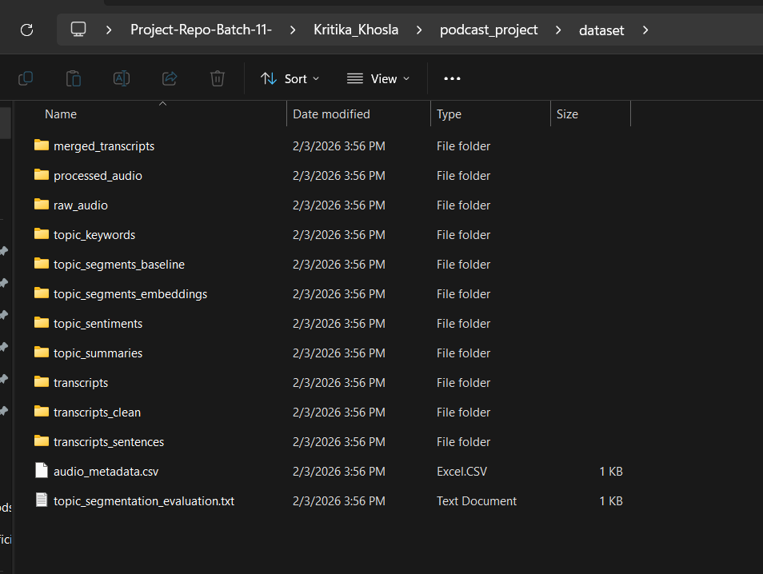

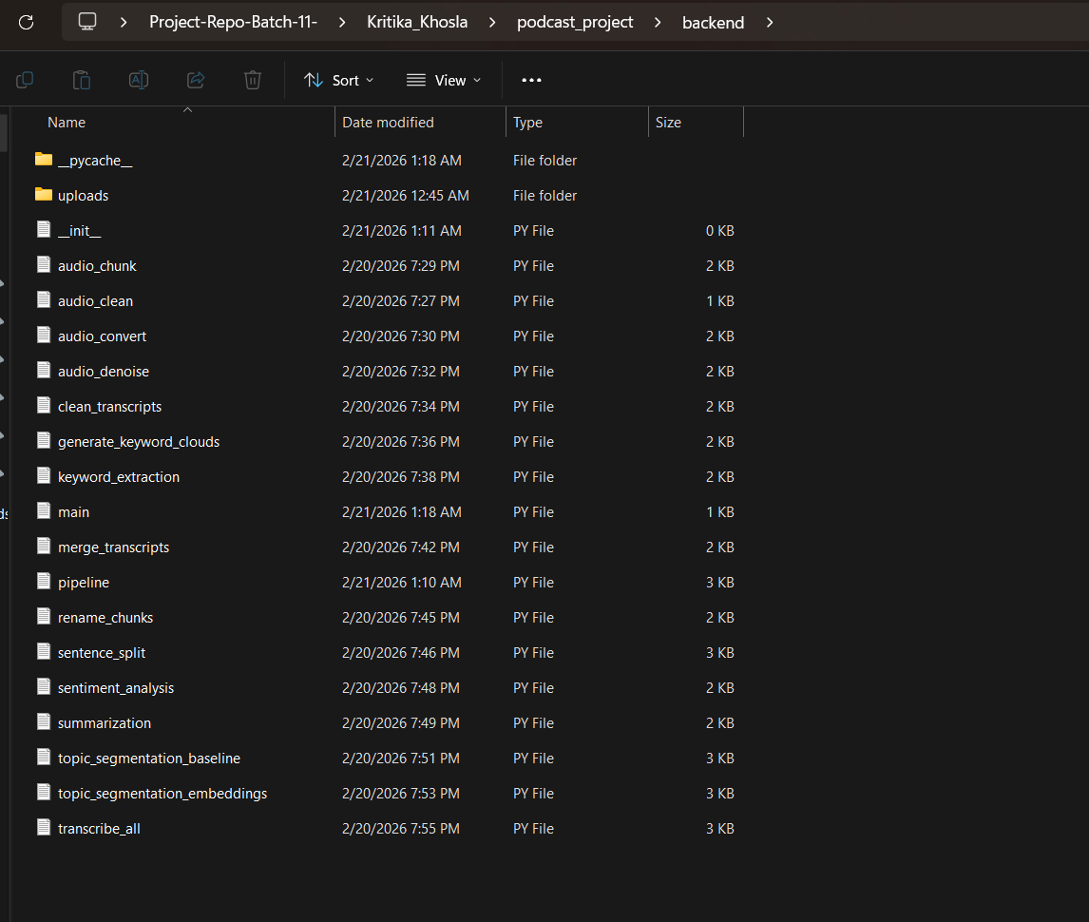

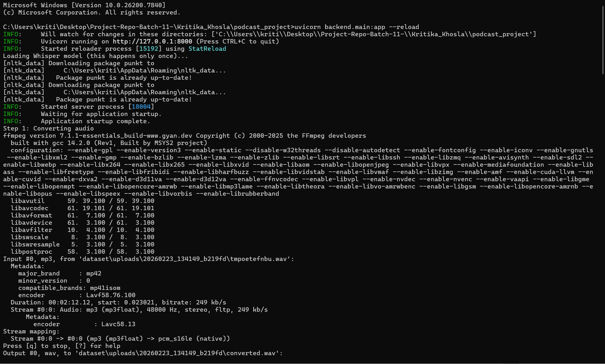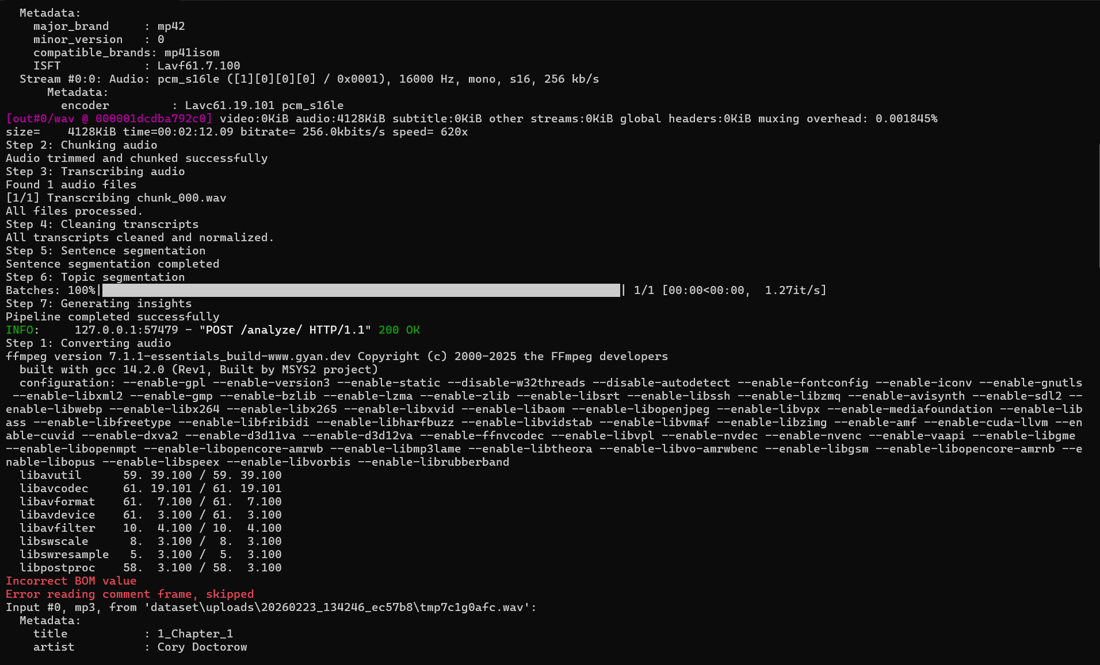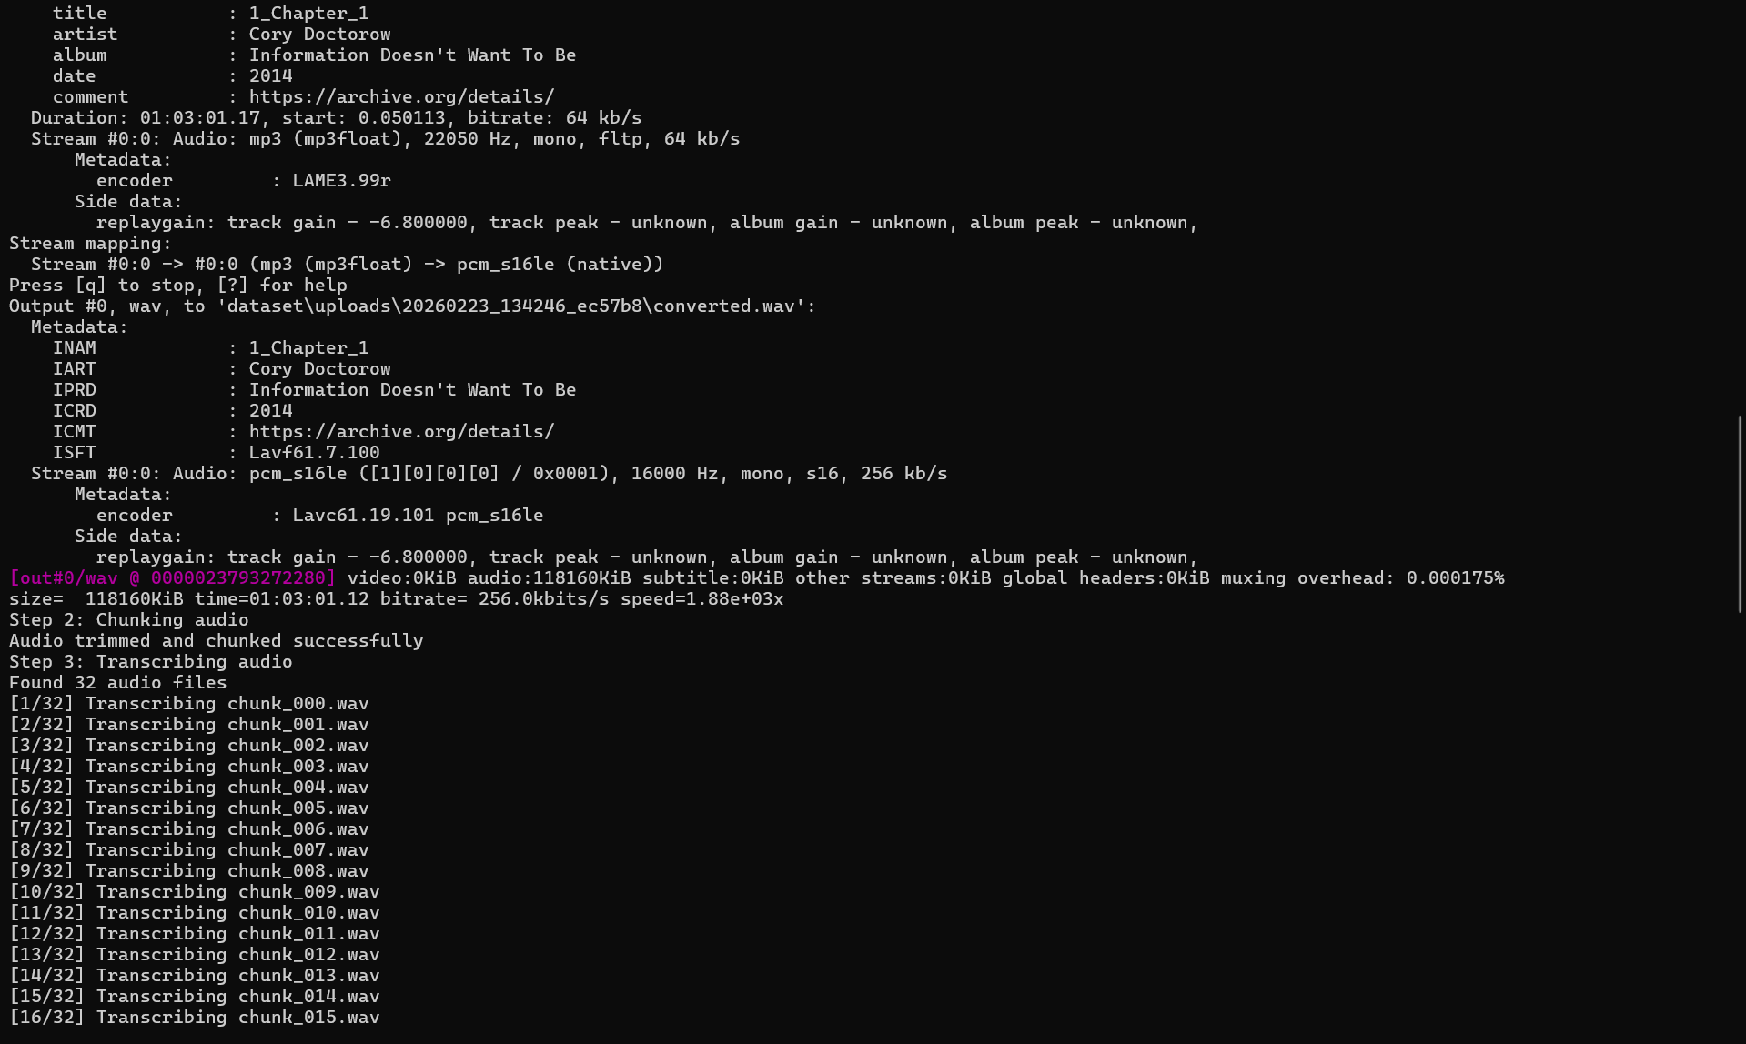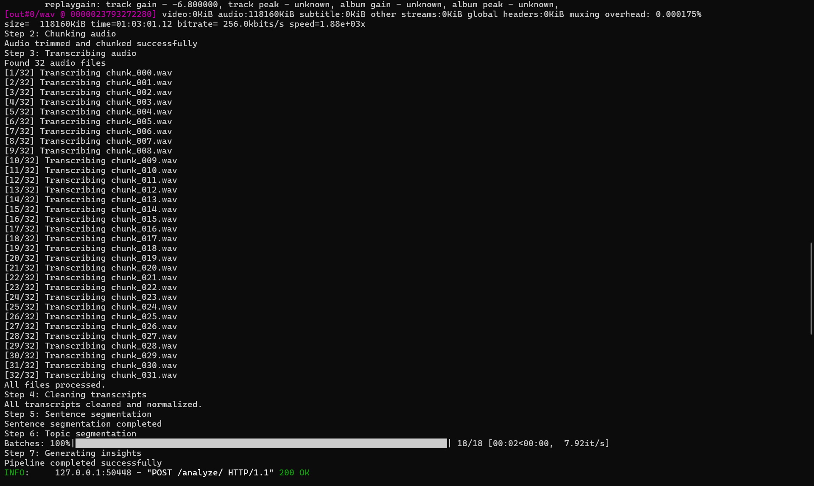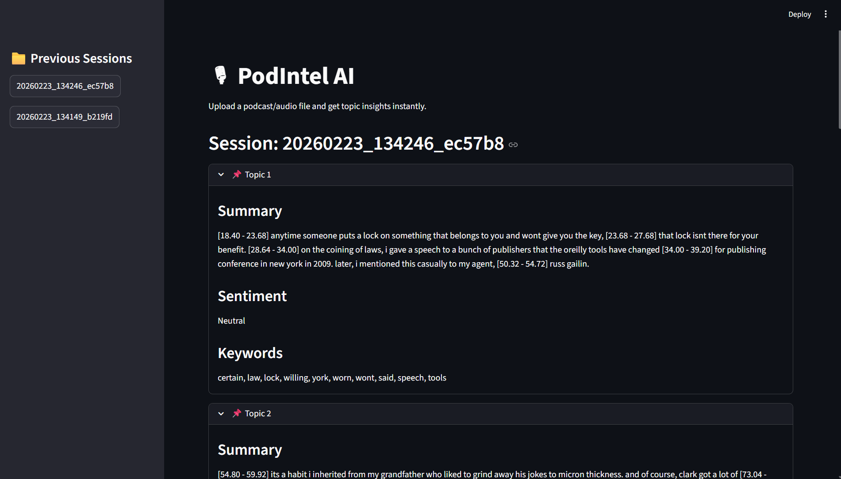

6. Project Folder Structure
podcast_project/
│
├── app.py (Streamlit Frontend)
├── backend/
│ ├── main.py
│ ├── pipeline.py
│ ├── audio_convert.py
│ ├── audio_chunk.py
│ ├── transcribe_all.py
│ ├── clean_transcripts.py
│ ├── sentence_split.py
│ ├── topic_segmentation_embeddings.py
│ ├── summarization.py
│ ├── sentiment_analysis.py
│ ├── keyword_extraction.py
│
└── dataset/uploads/ (Session-based results)

7. Key Features
- Session-based isolated processing
- Automatic topic detection
- Extractive text summarization
- Sentiment classification (Positive/Negative/Neutral)
- Clean keyword extraction
- Frontend session history display

8. Challenges Faced
- Managing large audio files
- Whisper model loading time
- Cleaning timestamp noise from transcripts
- Avoiding duplicate session mixing
- Optimizing chunk size and topic segmentation

9. Future Enhancements
- Use faster Whisper models
- Deploy on cloud (AWS/GCP)
- Add speaker diarization
- Add downloadable PDF reports
- Add real-time transcription

10. Conclusion
PodIntel AI successfully demonstrates an end-to-end AI pipeline for podcast analysis, integrating speech recognition, NLP, and embedding-based topic segmentation into a clean web interface. The system is modular, scalable, and ready for further enhancement.

